Experiment – 1

Login page -

<!DOCTYPE html>
<html lang="en">

<head>
<meta charset="UTF-8">
<meta name="viewport" content="width=device-width, initial-scale=1.0">
<title>login</title>
<style>
* {
margin: 0;
padding: 0;
}

.con {
height: 100vh;
width: 100vw;
background-color: rgb(227, 241, 227);
display: flex;
}

.box {
margin: auto;
width: 400px;
height: 500px;
background-color: rgba(119, 118, 118, 0.411);
border-radius: 10px;
margin-top: 100px;
display: flex;
flex-direction: column;
}

.brand {
color: rgb(5, 5, 5);
font-size: 80px;
font-weight: 900;
margin: 20px auto;
}

.brand:hover {
transform: scale(1.1);
color: rgb(0, 255, 0);
}

.email,
.password {
border: 1px solid white;
border-radius: 5px;
background-color: rgba(0, 0, 0, 0.111);
height: 30px;
margin: 10px 15px;
padding: 10px;
color: white;
}

.btn {
padding: 10px;
width: 150px;
margin: 10px auto;
border-radius: 10px;
font-size: 18px;
font-weight: 600;
}

.btn:hover {
transform: scale(1.05);
color: white;
background-color: black;
border: 1px solid white;
}

.do {
color: grey;
margin: 10px auto;
}

.sing {
color: white;
font-size: 18px;
margin: 0px auto;
}
</style>
</head>

<body>
<div class="con">
<div class="box">
<div class="brand">Book Store</div> <input class="email" type="email" name="email" id="email"
placeholder="Email"> <input class="password" type="password" placeholder="Password"> <button
class="btn">Log in</button>
<div class="do">Do not have an account</div>
<div class="sing">Sing up</div>
</div>
</div>
<script>
let redirect = document.getElementsByClassName("btn")[0]
redirect.addEventListener("click", () => { window.location.href = "home.html"; })
</script>
</body>

</html>

Output 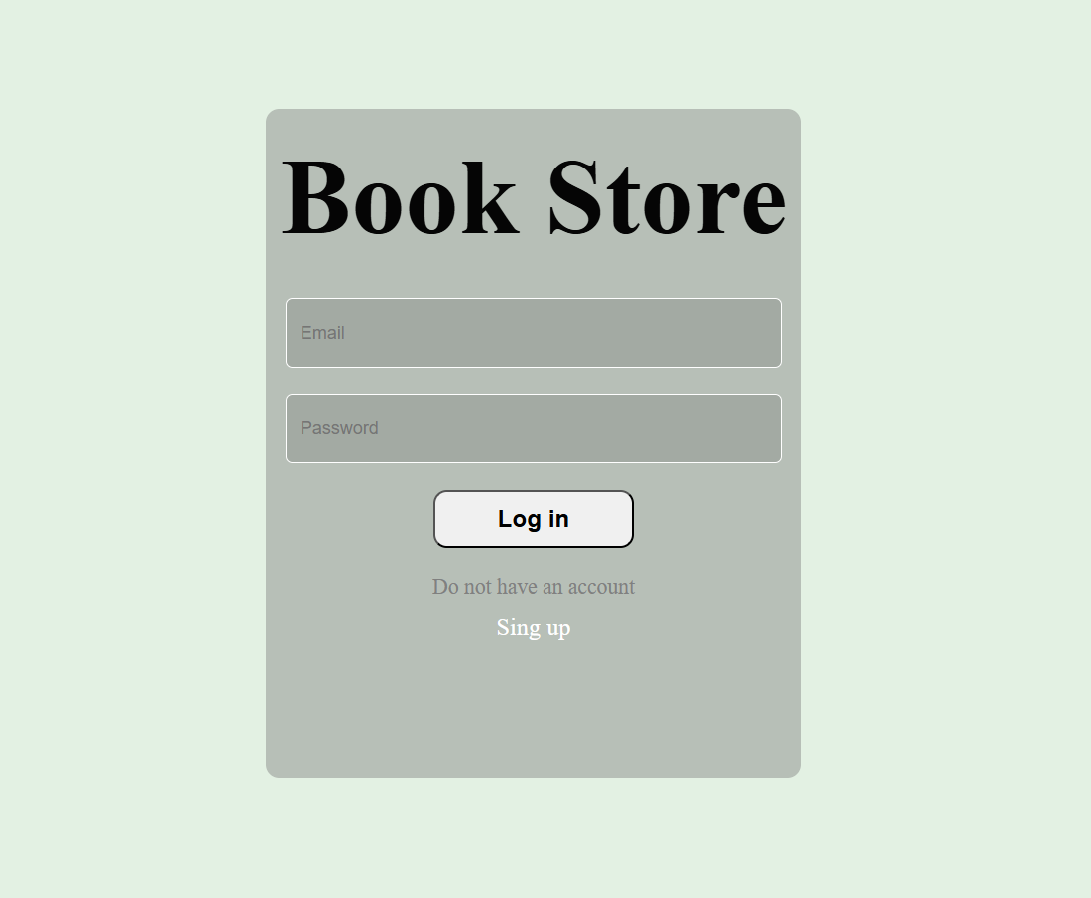–

Home page –
<!DOCTYPE html>
<html lang="en">

<head>
<meta charset="UTF-8">
<meta name="viewport" content="width=device-width, initial-scale=1.0">
<title>home</title>

<style>
* {
padding: 0;
margin: 0;
}

.bottom {
display: flex;
justify-content: space-around;
font-size: 20px;
font-weight: 600;
background-color: rgb(196, 196, 196);
padding: 10px;
position: fixed;
bottom: 0px;
width: 100vw;
}

.home, .cataloge, .profile {
color: greenyellow;
padding: 10px;
border-radius: 10px;
background-color: black;
}

.home:hover , .cataloge:hover , .profile:hover {
color: black;
background-color: greenyellow;
}
.header {
background-color: black;
color: white;
font-size: 30px;
}

.head {
font-weight: 600;
padding: 10px;
}

.t1 {
font-size: 25px;
font-weight: 600;
padding: 10px;
}

.book {
width: 300px;
height: 470px;
border: 1px solid black;
margin: auto;
border-radius: 10px;
background-color: rgb(232, 232, 232);
display: flex;
flex-direction: column;
align-items: center;
gap: 5px;
margin-top: 10px;
margin-bottom: 10px;
}

img {
width: 240px;
border-radius: 10px;
}

.bookimg {
margin: 10px 30px;
}

.bookname {
font-size: 18px;
font-weight: 700;
}

.bookbtn {
background-color: black;
color: white;
padding: 10px;
border: 0px;
border-radius: 5px;

}

.booklast {
margin-bottom: 70px;
}
</style>
</head>

<body>
<div class="con">
<div class="start">
<div class="header">
<div class="head">Book Store</div>
</div>
<div class="t1">Most sold of the week</div>
<div class="card">
<div class="book">
<div class="bookimg">
<img
src="https://media.springernature.com/full/springer-static/cover-hires/book/978-1-4842-9792-6">
</div>
<div class="bookname">Database-Driven Web Development</div>
<div class="bookauthor">Thomas Valentine</div>
<div>
<button class="bookbtn">Read Now</button>
</div>
</div>
</div>
<div class="t1">Most liked of the week</div>
<div class="card">
<div class="booklast book">
<div class="bookimg">
<img
src="https://media.springernature.com/full/springer-static/cover-hires/book/978-1-4842-9792-6">
</div>
<div class="bookname">Database-Driven Web Development</div>
<div class="bookauthor">Thomas Valentine</div>
<div>
<button class="bookbtn">Read Now</button>
</div>
</div>
</div>
<div class="bottom">
<div class="home">Home</div>
<div class="cataloge">Explore</div>
<div class="profile">Profile</div>
</div>
</div>
</div>

<script>

let profile = document.getElementsByClassName("profile")[0]

profile.addEventListener("click", () => {
window.location.href = "biodata.html";
})
let cataloge = document.getElementsByClassName("cataloge")[0]

cataloge.addEventListener("click", () => {
window.location.href = "catalog.html";
})
let home = document.getElementsByClassName("home")[0]

home.addEventListener("click", () => {
window.location.href = "home.html";
})
</script>
</body>

</html>

Output –
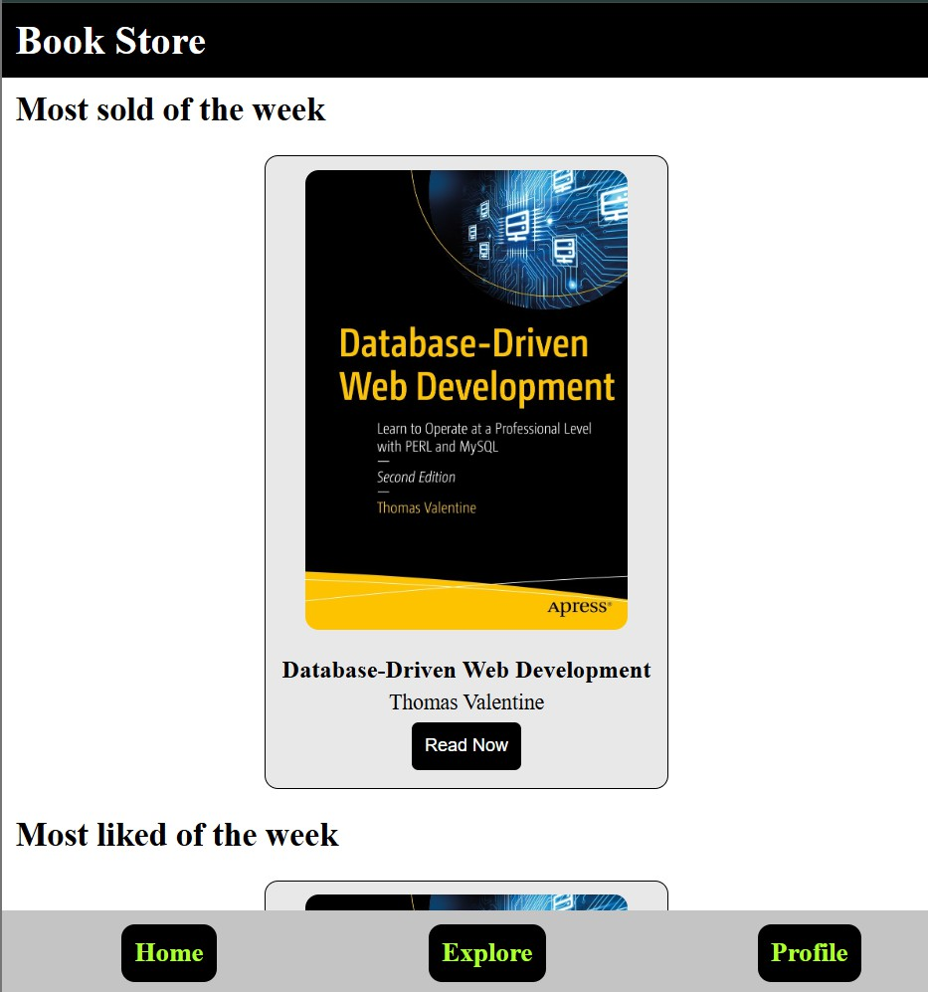

Catalogue page –

<!DOCTYPE html>
<html lang="en">

<head>
<meta charset="UTF-8">
<meta name="viewport" content="width=device-width, initial-scale=1.0">
<title>Explore</title>

<style>
* {
padding: 0;
margin: 0;
}

.header {
background-color: black;
color: white;
font-size: 30px;
}

.head {
font-weight: 600;
padding: 10px;
}

.t1 {
font-size: 25px;
font-weight: 600;
padding: 10px;
}

.book {
width: 300px;
height: 470px;
border: 1px solid black;
margin: auto;
border-radius: 10px;
background-color: rgb(232, 232, 232);
display: flex;
flex-direction: column;
align-items: center;
gap: 5px;
margin-top: 10px;
margin-bottom: 10px;
}

img {
width: 240px;
border-radius: 10px;
}

.bookimg {
margin: 10px 30px;
}

.bookname {
font-size: 18px;
font-weight: 700;
}

.bookbtn {
background-color: black;
color: white;
padding: 10px;
border: 0px;
border-radius: 5px;
}

.booklast {
margin-bottom: 70px;
}

.grid {
display: grid;
grid-template-columns: 1fr 1fr 1fr;
}
</style>
</head>

<body>
<div class="con">
<div class="start">
<div class="header">
<div class="head">Explore Books</div>
</div>
<div class="t1">Most sold of the week</div>
<div class="grid">
<div class="card">
<div class="book booklast">
<div class="bookimg">
<img
src="https://media.springernature.com/full/springer-static/cover-hires/book/978-1-4842-9792-6">
</div>
<div class="bookname">Database-Driven Web Development</div>
<div class="bookauthor">Thomas Valentine</div>
<div>
<button class="bookbtn">Read Now</button>
</div>
</div>
</div>
<div class="card">
<div class="book booklast">
<div class="bookimg">
<img
src="https://media.springernature.com/full/springer-static/cover-hires/book/978-1-4842-9792-6">
</div>
<div class="bookname">Database-Driven Web Development</div>
<div class="bookauthor">Thomas Valentine</div>
<div>
<button class="bookbtn">Read Now</button>
</div>
</div>
</div>
<div class="card">
<div class="book booklast">
<div class="bookimg">
<img
src="https://media.springernature.com/full/springer-static/cover-hires/book/978-1-4842-9792-6">
</div>
<div class="bookname">Database-Driven Web Development</div>
<div class="bookauthor">Thomas Valentine</div>
<div>
<button class="bookbtn">Read Now</button>
</div>
</div>
</div>
<div class="card">
<div class="book booklast">
<div class="bookimg">
<img
src="https://media.springernature.com/full/springer-static/cover-hires/book/978-1-4842-9792-6">
</div>
<div class="bookname">Database-Driven Web Development</div>
<div class="bookauthor">Thomas Valentine</div>
<div>
<button class="bookbtn">Read Now</button>
</div>
</div>
</div>
<div class="card">
<div class="book booklast">
<div class="bookimg">
<img
src="https://media.springernature.com/full/springer-static/cover-hires/book/978-1-4842-9792-6">
</div>
<div class="bookname">Database-Driven Web Development</div>
<div class="bookauthor">Thomas Valentine</div>
<div>
<button class="bookbtn">Read Now</button>
</div>
</div>
</div>
<div class="card">
<div class="book booklast">
<div class="bookimg">
<img
src="https://media.springernature.com/full/springer-static/cover-hires/book/978-1-4842-9792-6">
</div>
<div class="bookname">Database-Driven Web Development</div>
<div class="bookauthor">Thomas Valentine</div>
<div>
<button class="bookbtn">Read Now</button>
</div>
</div>
</div>
<div class="card">
<div class="book booklast">
<div class="bookimg">
<img
src="https://media.springernature.com/full/springer-static/cover-hires/book/978-1-4842-9792-6">
</div>
<div class="bookname">Database-Driven Web Development</div>
<div class="bookauthor">Thomas Valentine</div>
<div>
<button class="bookbtn">Read Now</button>
</div>
</div>
</div>
<div class="card">
<div class="book booklast">
<div class="bookimg">
<img
src="https://media.springernature.com/full/springer-static/cover-hires/book/978-1-4842-9792-6">
</div>
<div class="bookname">Database-Driven Web Development</div>
<div class="bookauthor">Thomas Valentine</div>
<div>
<button class="bookbtn">Read Now</button>
</div>
</div>
</div>
<div class="card">
<div class="book booklast">
<div class="bookimg">
<img
src="https://media.springernature.com/full/springer-static/cover-hires/book/978-1-4842-9792-6">
</div>
<div class="bookname">Database-Driven Web Development</div>
<div class="bookauthor">Thomas Valentine</div>
<div>
<button class="bookbtn">Read Now</button>
</div>
</div>
</div>
</div>
<div class="t1">Most liked of the week</div>

<div class="grid">
<div class="card">
<div class="booklast book">
<div class="bookimg">
<img
src="https://media.springernature.com/full/springer-static/cover-hires/book/978-1-4842-9792-6">
</div>
<div class="bookname">Database-Driven Web Development</div>
<div class="bookauthor">Thomas Valentine</div>
<div>
<button class="bookbtn">Read Now</button>
</div>
</div>
</div>
<div class="card">
<div class="booklast book">
<div class="bookimg">
<img
src="https://media.springernature.com/full/springer-static/cover-hires/book/978-1-4842-9792-6">
</div>
<div class="bookname">Database-Driven Web Development</div>
<div class="bookauthor">Thomas Valentine</div>
<div>
<button class="bookbtn">Read Now</button>
</div>
</div>
</div>
<div class="card">
<div class="booklast book">
<div class="bookimg">
<img
src="https://media.springernature.com/full/springer-static/cover-hires/book/978-1-4842-9792-6">
</div>
<div class="bookname">Database-Driven Web Development</div>
<div class="bookauthor">Thomas Valentine</div>
<div>
<button class="bookbtn">Read Now</button>
</div>
</div>
</div>
<div class="card">
<div class="booklast book">
<div class="bookimg">
<img
src="https://media.springernature.com/full/springer-static/cover-hires/book/978-1-4842-9792-6">
</div>
<div class="bookname">Database-Driven Web Development</div>
<div class="bookauthor">Thomas Valentine</div>
<div>
<button class="bookbtn">Read Now</button>
</div>
</div>
</div>
<div class="card">
<div class="booklast book">
<div class="bookimg">
<img
src="https://media.springernature.com/full/springer-static/cover-hires/book/978-1-4842-9792-6">
</div>
<div class="bookname">Database-Driven Web Development</div>
<div class="bookauthor">Thomas Valentine</div>
<div>
<button class="bookbtn">Read Now</button>
</div>
</div>
</div>
<div class="card">
<div class="booklast book">
<div class="bookimg">
<img
src="https://media.springernature.com/full/springer-static/cover-hires/book/978-1-4842-9792-6">
</div>
<div class="bookname">Database-Driven Web Development</div>
<div class="bookauthor">Thomas Valentine</div>
<div>
<button class="bookbtn">Read Now</button>
</div>
</div>
</div>
<div class="card">
<div class="booklast book">
<div class="bookimg">
<img
src="https://media.springernature.com/full/springer-static/cover-hires/book/978-1-4842-9792-6">
</div>
<div class="bookname">Database-Driven Web Development</div>
<div class="bookauthor">Thomas Valentine</div>
<div>
<button class="bookbtn">Read Now</button>
</div>
</div>
</div>
<div class="card">
<div class="booklast book">
<div class="bookimg">
<img
src="https://media.springernature.com/full/springer-static/cover-hires/book/978-1-4842-9792-6">
</div>
<div class="bookname">Database-Driven Web Development</div>
<div class="bookauthor">Thomas Valentine</div>
<div>
<button class="bookbtn">Read Now</button>
</div>
</div>
</div>
<div class="card">
<div class="booklast book">
<div class="bookimg">
<img
src="https://media.springernature.com/full/springer-static/cover-hires/book/978-1-4842-9792-6">
</div>
<div class="bookname">Database-Driven Web Development</div>
<div class="bookauthor">Thomas Valentine</div>
<div>
<button class="bookbtn">Read Now</button>
</div>
</div>
</div>
</div>
</div>
</div>

</body>

</html>

Output –

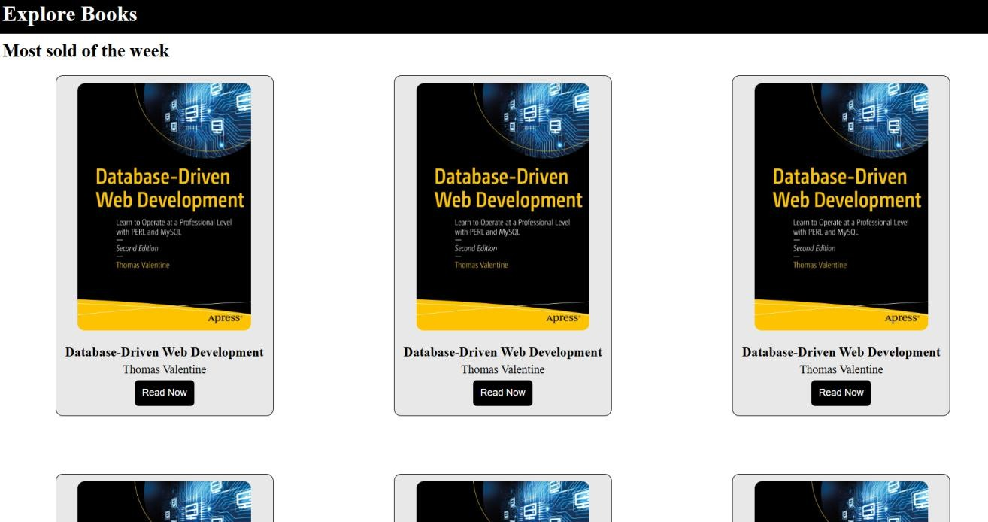

Biodata page –
<!DOCTYPE html>
<html lang="en">

<head>
<meta charset="UTF-8">
<meta name="viewport" content="width=device-width, initial-scale=1.0">
<title>first experiment</title>
<style>

* {
margin: 0;
padding: 0;
}
.con {
background-color: rgb(29, 29, 29);
width: 100vw;
height: 100vh;
}

.start {
display: flex;
}

.border {
border-radius: 5px;
width: 600px;
height: 80vh;
border: 0px solid black;
margin: auto;
margin-top: 50px;
color: white; background-color: rgb(49, 54, 49);
}

.right {
margin-top: 40px;
margin-left: 15px;
}

.tag {
font-size: 20px;
font-weight: 600;
}

.info {
display: flex;
margin-top: 10px;
}

.names {
font-size: 17px;
}

.left {
justify-content: end;
}

img {
width: 150px;
height: 150px;
margin-left: 225px;
margin-top: 30px;
border-radius: 90px;
}
</style>
</head>

<body>
<div class="con">
<div class="start">
<div class="border">
<div class="left">
<div class="img"> <img
src="https://tse3.mm.bing.net/th/id/OIP.nKc0BH_t6LAViz3N2SedfAHaE7?rs=1&pid=ImgDetMain&o=7&rm=3"
alt="profile photo"> </div>
</div>
<div class="right">
<div class="info">
<div class="tag">Name : </div>
<div class="names">Ajay Yadav</div>
</div>
<div class="info">
<div class="tag">Branch : </div>
<div class="names">Microelectronics and VLSI engineering</div>
</div>
<div class="info">
<div class="tag">DOB : </div>
<div class="names">10-07-2008</div>
</div>
<div class="info">
<div class="tag">Contact No. : </div>
<div class="names">9912536464</div>
</div>
<div class="info">
<div class="tag">Address : </div>
<div class="names">NIT KKR</div>
</div>
<div class="info">
<div class="tag">Hobby : </div>
<div class="names">Singing</div>
</div>
<div class="info">
<div class="tag">Github Page : </div> <a href="http://github.com/ajay11110">ajay1110</a>
</div>
</div>

</div>
</div>
</div>
</body>

</html>

Output –